**SPRINT-4**

Team ID -- PNT2022TMID37201

Project Name -- IoT Enabled Smart Farming Application.

**LOGIN SUCCESFUL**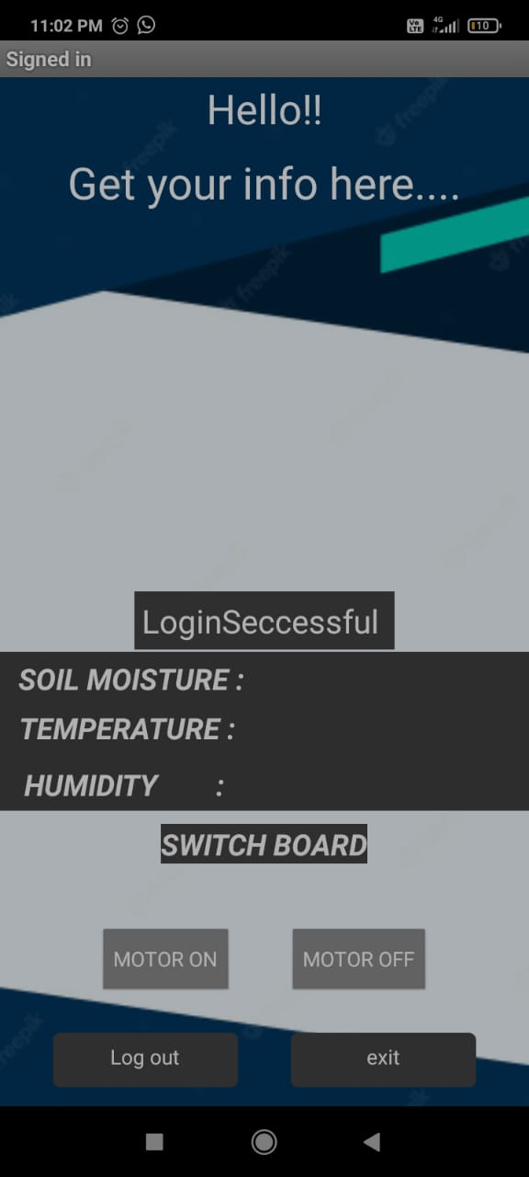

**DISPLAY TEMPERATURE , HUMIDITY , MOISTURE PARAMETERS**

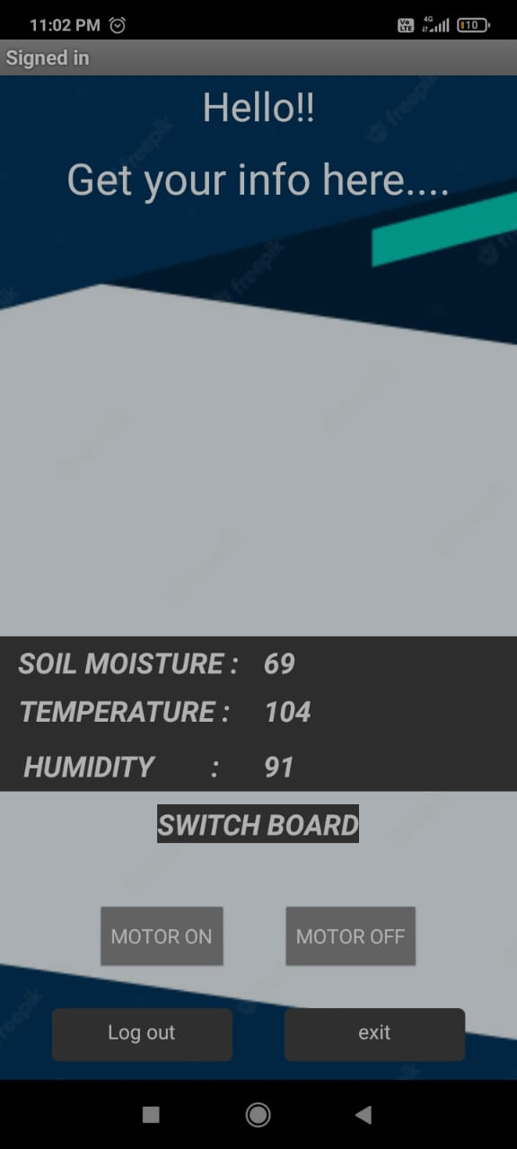

**AFTER GET THE REQUIRED INFORMATION , LOGOUT FROM THE APP BY CLICKING EXIT BUTTON.**